# Java Web Development Basics

# Exam Preparation

# Casebook

Exam Preparation problems for the [“Java Web Development Basics” course @ SoftUni](https://softuni.bg/courses/java-web-development-basics). Submit your solutions on the course page, so that you can be evaluated by your fellow colleagues.

**Casebook** is a Social Media Application. You have been tasked to implement this application for an unusually low price, by an unusually rich client. There are several requirements you must follow in the implementation.

## Database Requirements

The **Database** of the application needs to support **1 entity**:

### User

* Has an Username
* Has a Password
* Has an Gender
* Has Friends (other users)

Implement the entities with the **correct datatypes**, and implement **repositories** for them.

## Pages

### Index Page (logged out user)

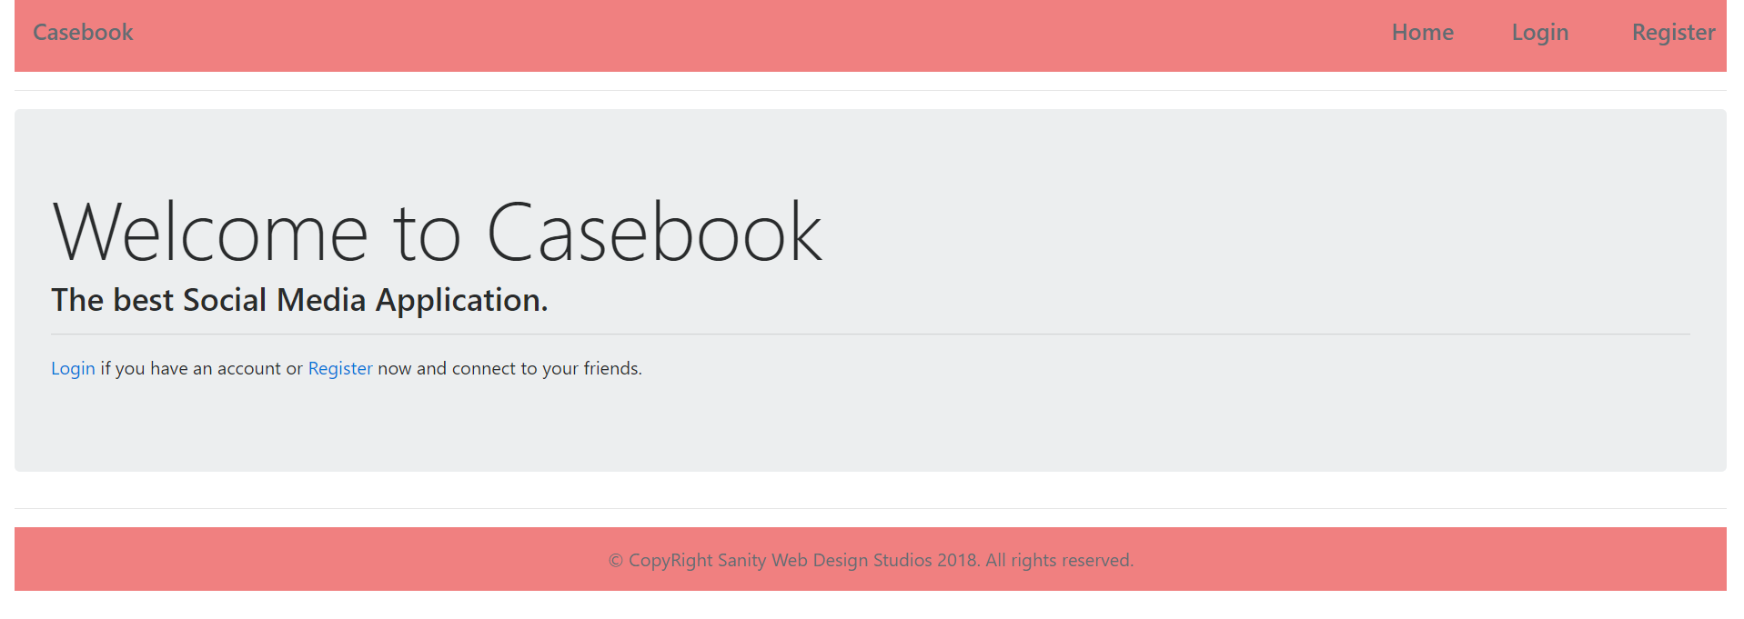

### Login Page (logged out user)

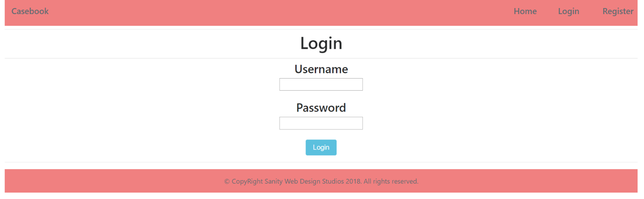

### Register Page (logged out user)

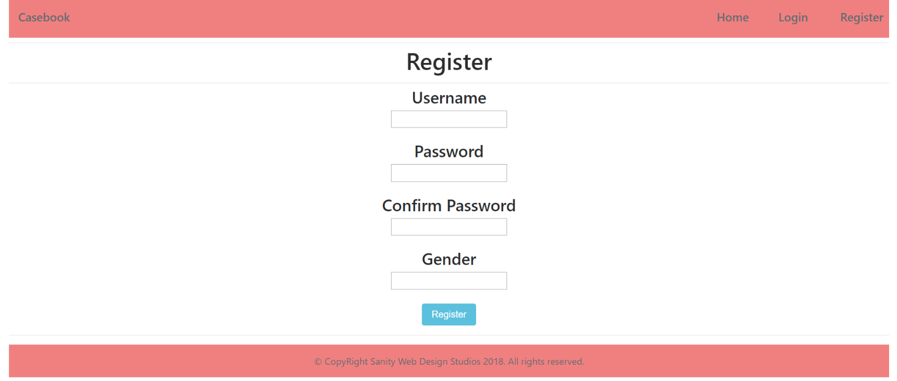

### Home Page (logged in user)

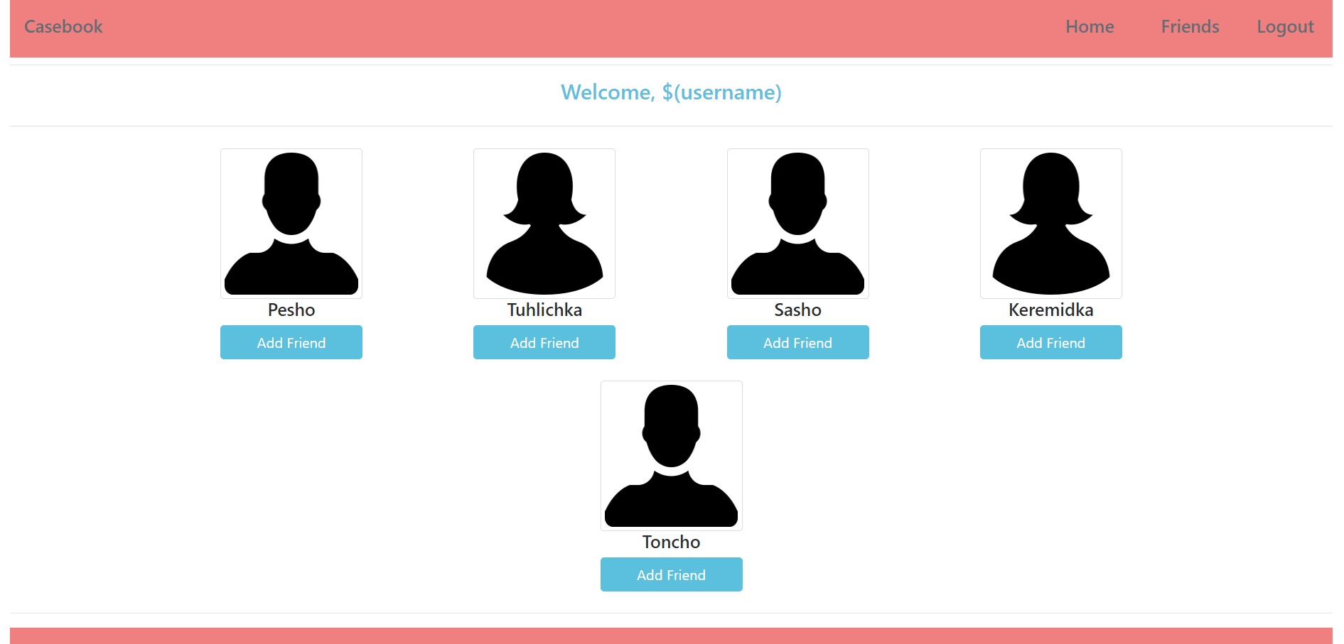

**NOTE**: People are visualized on the Home Page in **rows** by **4**.

### Friends Page (logged in user)

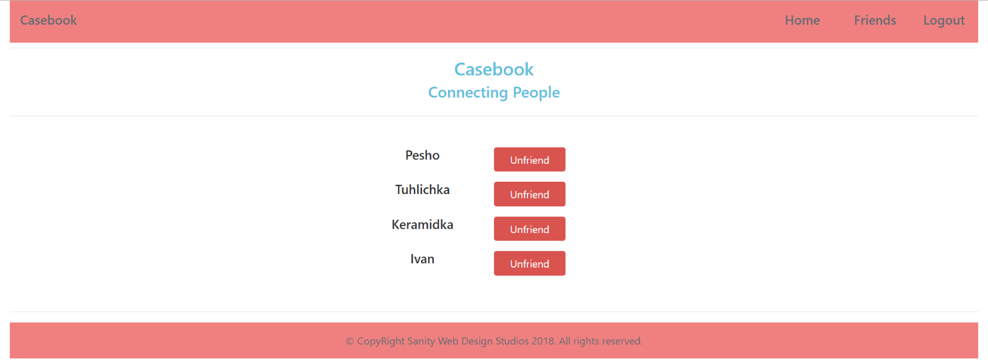

### Profile Page (logged in user)

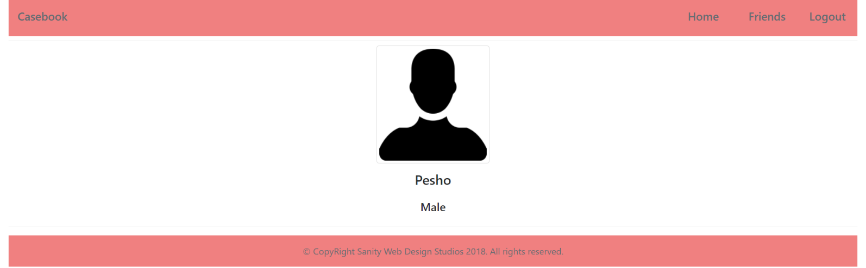

The templates have been given to you in the application skeleton, so make sure you implement the pages correctly.

**NOTE**: The templates should look **EXACTLY** as shown above.

**NOTE**: The templates do **NOT** **require** **additional** **CSS** for you to write. Only **bootstrap** and the **given css** are enough.

## Functionality

The Functionality Requirements describe the functionality that the **Application** must support.

The **application** should provide Guest (not logged in) users with the functionality to:

* Login
* Register
* **View** the Index page.

The **application** should provide Users (logged in) with the functionality to:

* Logout
* **View** all Users (Home page)
* **Add** Friends (Clicking on [Add Friend] button on Home page)
* **View** self (**logged-in user**) Profile (Clicking on [Welcome, $(username)] message on Home page)
* **View** all Friends (Friends page)
* **Remove** Friends (Clicking on [Unfriend] button on Friends page)
* **View** friend Profile (Clicking on a friend’s name on Friends page)

The **application** should provide **functionality** registering a User with **2 possible genders** for the time being – “Female”, “Male”.

The Home page should view **ONLY** the **users** which **are NOT friends** of the **currently logged in user** and **are NOT** the **currently logged in user**.

The Friends page should view **ONLY** the **users** which **ARE friends** of the **currently logged in user**.

The **application** should **store** its **data** into a MySQL database, using Hibernate native.

## Security

The Security Requirements are mainly access requirements. Configurations about which users can access specific functionalities and pages.

* Guest (not logged in) users can access Index page.
* Guest (not logged in) users can access Login page.
* Guest (not logged in) users can access Register page.
* Users (logged in) cannot access Guest pages.
* Users (logged in) can access Home page.
* Users (logged in) can access Friends page.
* Users (logged in) can access Add Friend functionality.
* Users (logged in) can access Remove Friend functionality.
* Users (logged in) can access Profile (self) page.
* Users (logged in) can access Profile (friend) page.
* Users (logged in) can access Logout functionality.

## Code Quality

Make sure you provide the best architecture possible. Structure your code into different modules, divide and conquer, follow the principles of high-quality code. You will be scored for the Code Quality and architecture of your project.

## Scoring

### Database – 10 points.

### Pages – 15 points.

### Functionality – 30 points.

### Security – 15 points.

### Code Quality – 30 points.